**Name: Atharva Velhankar  
Class: SE (A)  
Roll No: SEAD22508  
Subject: IOTL**

**Lab Practical 13**

**Problem Statement:**Study of ThingSpeak – an API and Web Service for the Internet of Things (Mini Project: Same can be done parallel with PBL).

**//Code :**

import requests

import time

import random

channel_id = 394744 # PUT CHANNEL ID HERE

write_key = 'AAOG612RJT5LW21R' # PUT YOUR WRITE KEY HERE

read_key = 'TSPKJB230K65QPJQ' # PUT YOUR READ KEY HERE

if __name__ == "__main__":

while True:

val = random.randint(0,99)

#print(val)

URL = 'http://api.thingspeak.com/update?api_key=%s&field1=%s' %(write_key,val)

#print(URL)

resp = requests.get(url=URL)

#print(resp.json())

# free account has an api limit of 15sec

time.sleep(30)

**OUTPUT:**

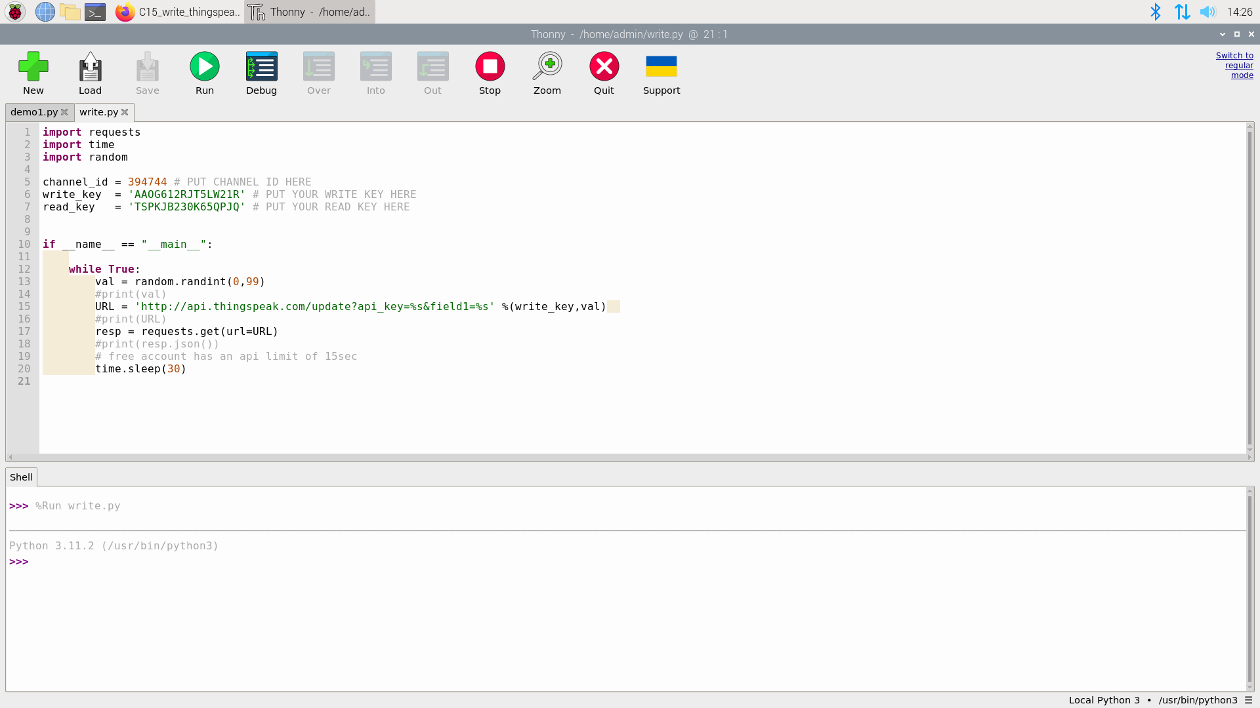

**Code:**

import requests

import json

import time

Key = 'TSPKJB230K65QPJQ'

channel = 394744

while True:

try:

#URL = 'http://api.thingspeak.com/channels/%s/feeds/last.json?' %(channel)

URL = 'http://api.thingspeak.com/channels/%s/field/1' %(channel)

#print(URL)

resp = requests.get(url=URL)

#print(resp)

resp = resp.json()['feeds'][-1]['field1']

print(resp)

time.sleep(0.3)

except KeyboardInterrupt:

exit()

**OUTPUT:**

